# 

**Independent Study Report**

**“Measurement of WAT with CPM”**

Submitted by:

Kriti Singh (1451057)

Submitted to

Dr. Michael Volk

Dr. Eduardo Pereyra

# Table of Contents

Table of Contents 2

List of Figures 3

List of Tables 3

1. Introduction 4

2. Literature Review 5

3. Brief Summary on the Procedure for Conducting Experiments 8

4. WAT Measurement Procedure : Cross Polarized Microscopy 13

5. MATLAB code for determing WAT and WDT 16

6. Effect of cooling rate on WAT 17

7. Sensitivity Analysis of the observed WAT on the CPM 18

8. Preliminary Analysis of different tests conducted on loop A and loop B 19

9.Conclusion 25

References 26

**List of Figures**

Figure Test overview 8

Figure Water content measurements 9

Figure 3 Differential pressures in the test section 9

Figure 4 Temperatures in the test section. 10

Figure 5 Process section temperatures 10

Figure 6 Temperatures in the wax deposition section 11

Figure 7 Sample pictures from bore scope observations 11

Figure 8 Spool #3 pigging at 60 F 12

Figure 9 Samples recovered during 60 F pigging. Spools #3 12

Figure 10 Initial picture taken at 24.3C on CPM 14

Figure 11 Screen is completely black at 50C 14

Figure 12 First crystals start to appear at between 20-20.5 C 15

Figure 13 A number of more crystals appear as the temp drops 15

Figure 14 A snapshot of excel file showing the graph and data produced by the

MATLAB code 16

Figure 15 A graph showing WAT vs cooling rate 17

Figure 16 WAT as a function of time and temperature for test AFA2015-010 19

Figure 17 WAT as a function of time and temperature for test AFA2015-012 20

Figure 18 WAT as a function of time and temperature for test AFA2015-013 21

Figure 19 WAT as a function of time and temperature for test AFB2015-009 22

Figure 20 WAT as a function of time and temperature for test AFB2015-010 23

Figure 21 WAT as a function of time and temperature for test AFB2015-011 24

**List of Tables**

Table 1 WAT corresponding to different cooling rate 17

Table 2 WAT observed for the repeated tests on CPM on the same sample 18

Table 3 WAT observed for different samples on the CPM for test AFA2015-010 19

Table 4 WAT observed for different samples on the CPM for test AFA2015-012 20

Table 5 WAT observed for different samples on the CPM for test AFA2015-013 21

Table 6 WAT observed for different samples on the CPM for test AFB2015-009 22

Table 7 WAT observed for different samples on the CPM for test AFB2015-010 23

Table 8 WAT observed for different samples on the CPM for test AFB2015-011 24

**Chapter 1: Introduction**

Wax deposition is a catastrophic issue in crude oil and gas/condensate systems that can render a pipe unstable. When the temperature of the oil falls below the Wax Appearance Temperature, WAT, the wax crystals precipitate out and gravitate to the pipe wall and sticks to it. The Trans-Alaska pipeline system, TAPS, which was designed and constructed in 1977 to move oil from the North Slope of Alaska to the northern most ice-free port in Valdez, Alaska, is currently facing the challenges posed by wax deposition. The throughput is declining more than 5 percent every year. Less oil means slower-moving oil, less turbulence, cooler crude temperature resulting in more wax dropping out of the oil and settling in the pipeline. In order to understand and mitigate the impacts of declining throughput in TAPS, the Alyeska Pipeline Service Company is currently working with the University of Tulsa. A test loop facility has been constructed which is a small scale model of the 48-inch TAPS, to simulate pipeline operating pipeline conditions at low levels of oil flow. Currently a number of tests are being conducted on flow loop A and flow loop B of the test facility.

The accurate measurement of WAT is very crucial for understanding the wax deposition phenomena. This report summarizes the work done and the results obtained from the various tests conducted on the Cross-Polarized Microscopy, CPM, for measuring the WAT of different oil samples obtained from the experiments conducted in flow loop A and loop B of the test facility.

**Executive Summary**

The report begins with a thorough literature review, chapter 2, of the milestone research that has been conducted in the past to understand and mitigate the paraffin deposition phenomena. This is followed by a brief summary of the procedure used to conduct the experiments on the flow loop of the test facility. Since, the main focus of this study is the accurate measurement of the WAT, the procedure used for measuring the WAT on CPM is described in detail in chapter 4. In order to cross-check the results, a MATLAB code was developed to find out the WAT as well as the Wax dissolution Temperature, WDT, using Image Processing. The concept is explained in further detail in chapter 5. The WAT is known to be dependent on the cooling rate and hence, chapter 6 is dedicated towards understanding the effect of different cooling rate on WAT. This is followed by a sensitivity analysis of the CPM procedure in chapter 7. The results obtained from testing samples in summarized in chapter 8. The objective of these tests is mainly to understand the effect of the temperature difference between bulk oil and the glycol and the time on WAT of the samples. The report ends with conclusions in chapter 9.

**Chapter 2: Literature Review**

Wax deposition is a major flow assurance problem during oil production in the petroleum industry. When the temperature of the crude oil falls below the Wax Appearance Temperature (WAT), the heavy components, such as paraffins, aromatics, naphthenics etc, precipitate and deposit on the walls of the oil pipeline in the form of waxy-oil gel. The deposited wax reduces the effective diameter of the pipeline which results in several flow assurance problems. Every year, millions of dollars are spent to remediate the pipelines that are blocked by wax. Hence, wax deposition is a serious issue and therefore, a lot of time and effort has been put in the past to come up with effective solutions to abate this problem. In this section of the report, the landmark work done in the past has been summarized briefly.

**Wax Deposition Mechanism**

The study on wax deposition mechanisms conducted by Burger et al (1981) led to the identification of four major deposition mechanisms: molecular diffusion of paraffin molecules dissolved in solution; shear dispersion; gravity settling and; Brownian diffusion of paraffin particles or wax precipitated out of solution. Many investigators have pointed out that molecular diffusion and shear diffusion are the two most important mechanisms that contribute to the paraffin deposition. Burger et al (1981) described the mechanism in detail. When the pipe wall is colder than the bulk oil, a temperature gradient is developed. Since the solubility of paraffin is a function of temperature, solid paraffin start forming near the pipe wall which leads to the development of a radial concentration gradient in the pipe wall and dissolved paraffin in the bulk oil starts moving towards the pipe wall where it continues to form solid crystals and deposit on the wall. Shear dispersion results in migration of solid particles from regions of high velocity to low velocity. Since, the velocity in the center of the pipe is higher than the velocity near the pipe wall, the wax particles move towards the wall where they can deposit. However, several investigators, Bern et al (1980), Brown et al (1993) claim that shear dispersion does not contribute much to paraffin deposition and molecular diffusion is the primary mechanism.

Lund (1998), Matzain (1996, 1999) and Apte (1999) presented thorough literature reviews on paraffin deposition under single and multiphase conditions during the TU Paraffin Deposition JIP, completed in 1999. Important research conducted in the past regarding various aspects of paraffin deposition, such as turbulent effects, deposition and temperature profile, surface roughness etc was discussed in detail.

**Important models**

A mathematical model for the prediction of wax deposition in turbulent pipeline flow was developed by B. A. Krasovitskii and V.I. Maron (1980). They studied the influence of time on the concentration of wax and the thickness of the layer. They reported that with the increase in the wax thickness, the heat dissipation capacity increases thereby increasing the bulk temperature. This results in an increase in the temperature of the layer thereby decreasing the migration flow of paraffin. Therefore, they observed that whereas the layer grows monotonically along the pipe where the thickness is small, a maximum appears at some local cross section of the pipe when the layer is thick.

Svendsen (1993) developed a mathematical model for quantitative prediction of wax deposition for each hydrocarbon component. The model predicts that the wax deposition can be reduced considerably even when the wall temperature is below the WAT, provided that the liquid/solid transition is small at the wall temperature. Expression for deposition as a function of time was obtained as a solution of differential equations derived from the principles of mass and energy conservation and the laws of diffusion.

Singh et al (2000) conducted experiments in three different flow loops and noticed a connection between the flow rate, the inner wall temperature, and the thickness of wax. He observed that an increase in the wall temperature results in a decrease in the thickness deposit, and consequently an increase in the wax content of the deposit. He concluded that this is due to the increase in the thermal resistance of the wax deposit. He noticed a similar effect of increase in the flow rate for which he gave an explanation that with the increase in the flow rate, the rate of heat transfer is higher. He developed a model which could well describe the physics related to the wax deposition process.

S. Todi et al (2006) developed a model that describes the deposition phenomena in relation to particle transport at all types of heat fluxes- positive, negative and zero. They concluded that the deposition is independent of the three different types of heat fluxes if the temperature is below WAT. In addition to that, they reported that the distribution of wax particles is established as a result of Brownian diffusion and shear dispersion.

**Important Experimental Work**

Several investigators have conducted experimental study on the measurement of wax deposition thickness with time. Lund (1998) performed experiments at the University of Tulsa as a part of the Joint Industry Project titled ‘Paraffin Deposition Prediction in Multiphase Flowlines and Wellbores”. He concentrated his research on determining the effect of different cooling temperatures on the paraffin deposition process. The oil temperature was kept constant while the outside temperature was varied and all the experiments were performed at a constant flow rate. He concluded that the effects of bulk oil temperature and the temperature difference are fairly consistent with the molecular diffusion model. He also pointed out that the wax depletion did not have a significant impact on the tests. He pointed out that neither molecular diffusion nor a shear dispersion model could adequately predict all the paraffin deposition phenomena that were observed and suggested the need for a more basic research at the molecular level.

Venkatesan (2004) conducted experiments in order to study the turbulent single-phase deposition phenomena as a part of his doctoral thesis. The bulk oil temperature as well as the cooling temperature was kept constant and the experiments were run with different flow rates between 10 and 25 gpm.

Hernandez (2002) conducted a series of experiments as a part of the Tulsa University Paraffin Deposition Projects (TUPDP). A total of nineteen single phase tests were successfully conducted in two different flow loops, with significantly different flow conditions in order to study the impact of flow rate, flow regime, temperature difference, and shear stripping and fluid properties on paraffin deposition process. It was concluded that the paraffin deposition process is highly dependent on the temperature difference between the oil and the glycol inlet temperatures. The difference in the deposit thickness was reported to be more significant for lower flow rates. A new model was developed based on the experimental results which gives better prediction in comparison to the TU model and the Singh et al. film model. The model also included the effects of aging and shear stripping.

Rosvold (2008) performed experiments at Statoil’s multiphase flow loop laboratory in Porsgrunn. A total of eight experiments were conducted. Of these, five experiments tested the effect of varying rate on deposition and keeping the oil inlet temperature constant while the remaining three tested the effect of oil temperature on deposition, keeping the flow rate constant. Based on the results, he concluded that increased condensate flow rate reduces the wax deposition thickness, confirming that a removal effect occurs in turbulent flow. He also reported that wax thickness increased with decreasing condensate temperature.

**Recent Developments: Application of intelligent modeling in wax deposition**

A number of models have been developed over the years in order to study the wax deposition phenomena based on experimental study. Even though these models have helped greatly in understanding the paraffin deposition phenomena, the time and money required to conduct the physical experiments is huge and the results may not be always accurate. Therefore, the industry today is increasingly adopting intelligent methods such as artificial neural networks (ANNs), support vector machines (SVMs), genetic algorithms (GAs), and fuzzy logic (FL) for data analysis and interpretation. Advanced predictive models can be developed which are more accurate, robust and less sensitive to noisy input data as compared to the models currently available.

Adeyami et al (2012) used Artificial Neural Network to predict the WAT for various hydrocarbon mixtures. Different permutations and combination of thermodynamic properties of twelve different hydrodynamic properties was used for training the model and the validation was done with the experimental data. It was reported that the Average Absolute Deviations (AAD%) for the ANN were less than those of the existing models.

Kamari et al (2013) proposed a robust soft computing approach namely, least-square support vector machine (LSSVM) modeling optimized with the coupled simulated annealing (CSA) to develop a predictive model for the estimation of wax deposition. The accuracy was reported to be higher than the existing neural network and multisolid models.

Very recently, Kamali Et al (2015) presented the results obtained from a relatively new model Adaptive network based fuzzy interference system, ANFIS. A fuzzy neural system is a fuzzy system that determines its parameters from training samples processed by the learning algorithm inspired by neural network theory. It was concluded that the ANFIS model could be used to predict the wax deposition thickness in single-phase turbulent flow rate and can be used in the oil and gas industry.

**Chapter 3: Summary of the Procedure of the Experiments Conducted in the Test Facility**

**Test Conditions**

The initial test conditions are different for different tests which will be covered in detail in the later sections of the report. However, the standard procedure is same for carrying out all the tests. The oil is added from drums and in order to simulate the exact flow conditions, the dead oil is converted to live oil by adding NGLs. The initial water content is measured and the cooling ramp is set to obtain the desired test temperature. In order to maintain the test temperature, the temperature control is used to set the Sylthern temperature of 60F. The system is maintained at the test temperature for a required number of days prior to shutting down and pigging.

Different variables are measured over the test period. Figure 1 to 6, shows the test overview, water content measurement, pressure drop along the test section, temperature in the test section, the process temperature, and the details of the temperatures in the wax deposition section respectively, of the test AFB2015-010 on the flow loop B.

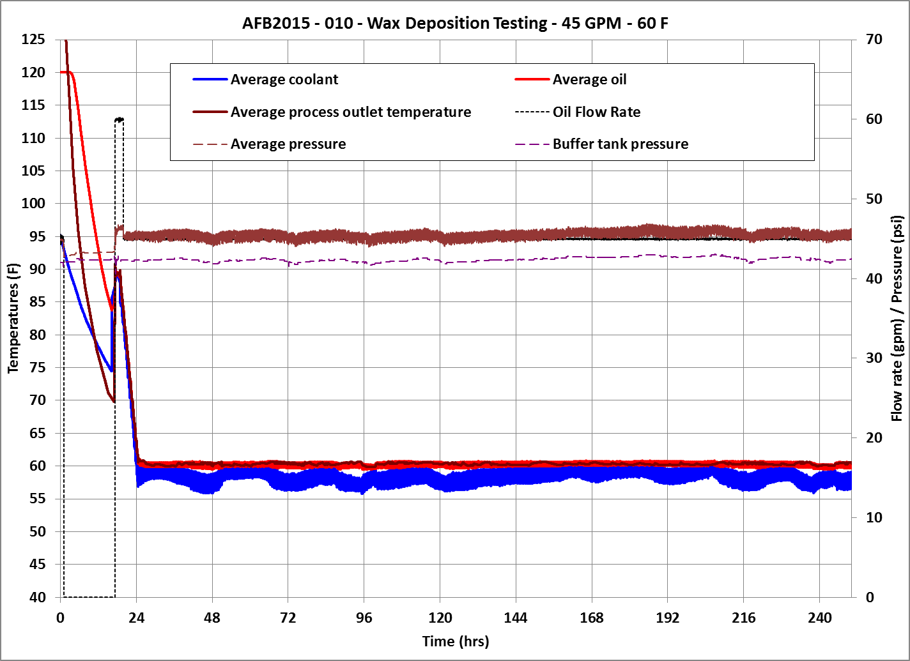

Figure 1 – Test overview

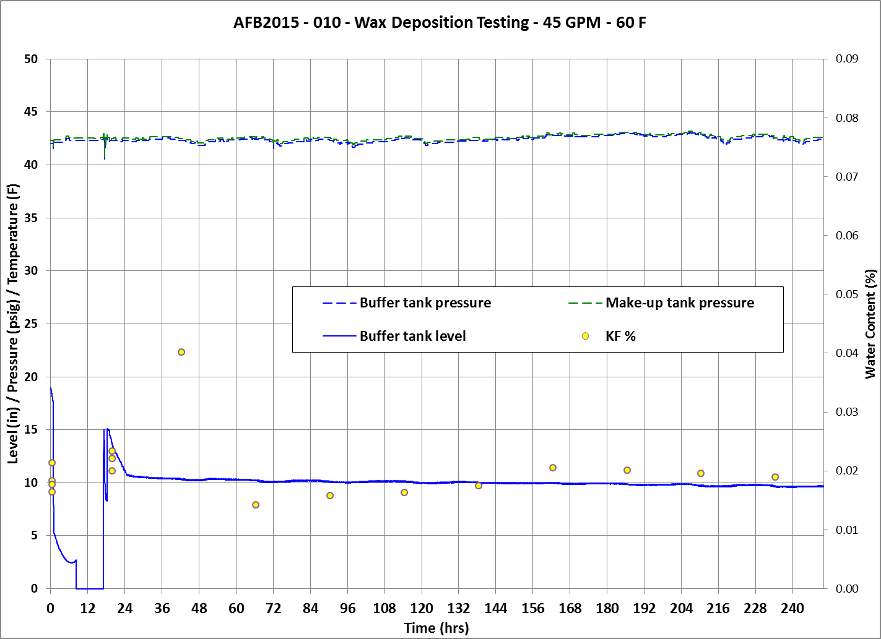

Figure 2 – Water content measurements

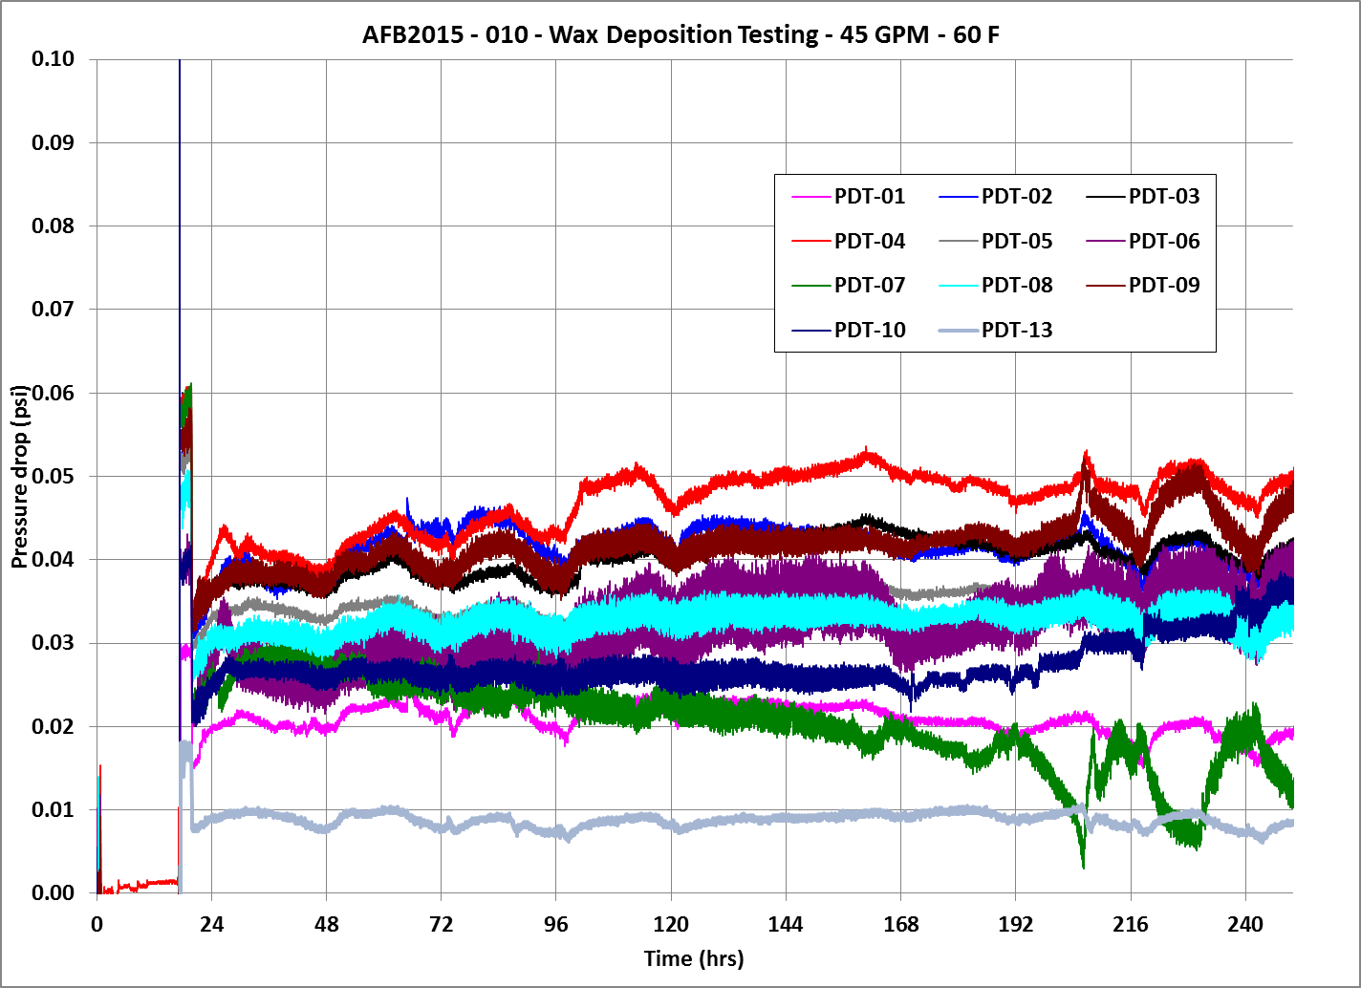

Figure 3 – Differential pressures in the test section

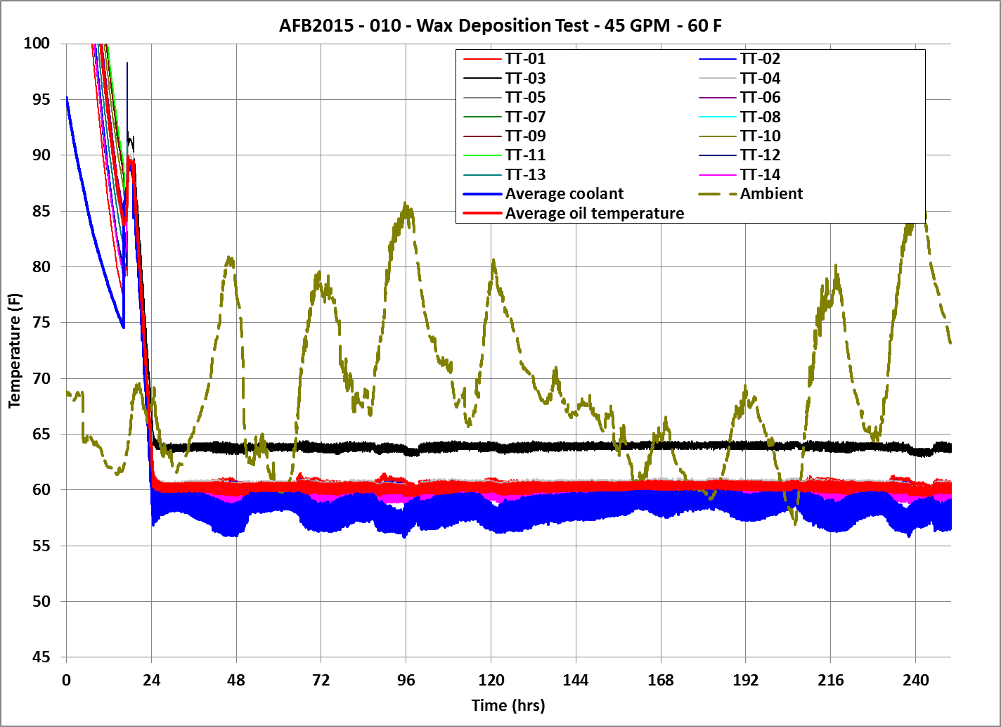

Figure 4 – Temperatures in the test section

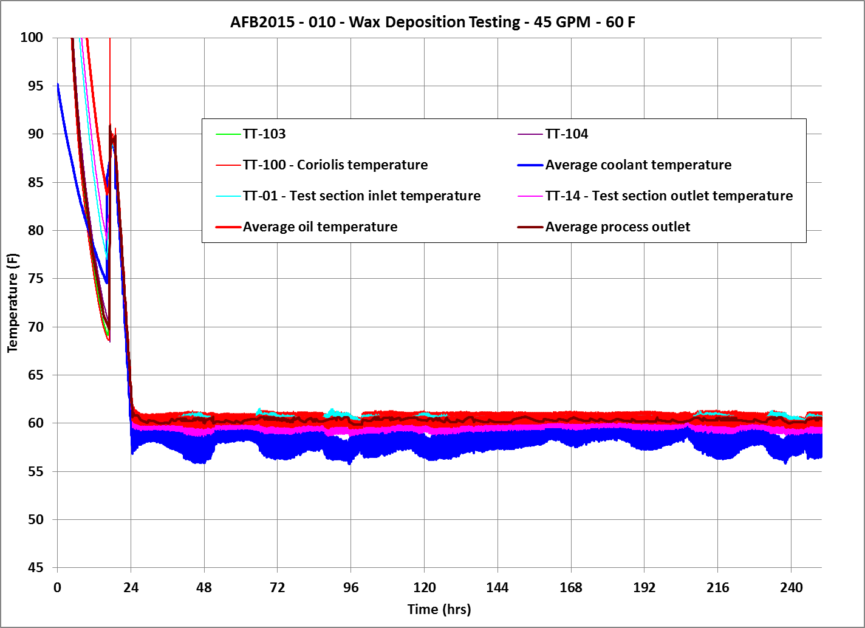  
Figure 5 – Process section temperatures

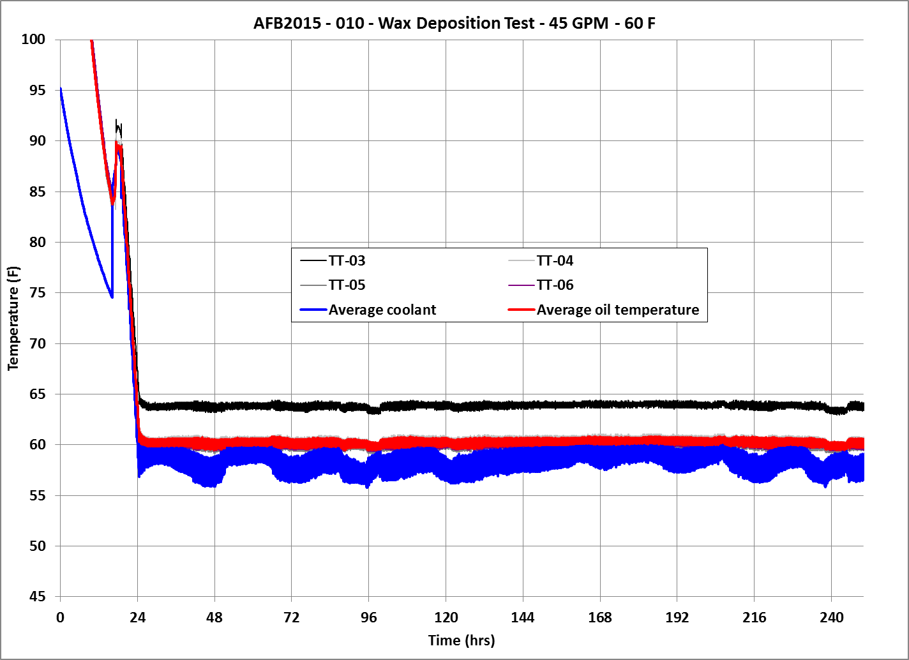  
Figure 6 – Temperatures in the wax deposition section

**Pigging and wax sampling**

The wax deposition spools are isolated, drained and the connecting spools are removed. Bore scope videos are taken before and after pigging. Sample pictures of before and after pigging for test AFB2015-010 is shown below in figure 7. The pigs used are the 85 durometer pigs. The same pigs are dedicated to each spool. To prevent moisture ingress during pigging, the ends of the spools are capped immediately after opening them up to atmosphere. Figures 8 shows the pigging process for each spool #3 of test AFB2015-010, while figure 9 shows the samples recovered during pigging.

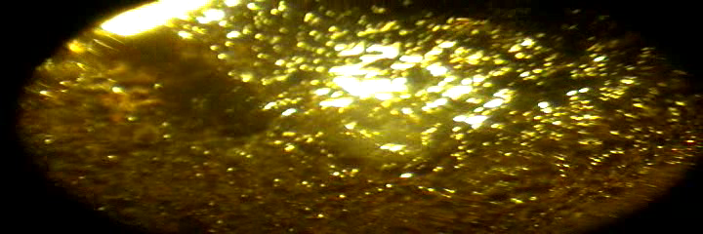 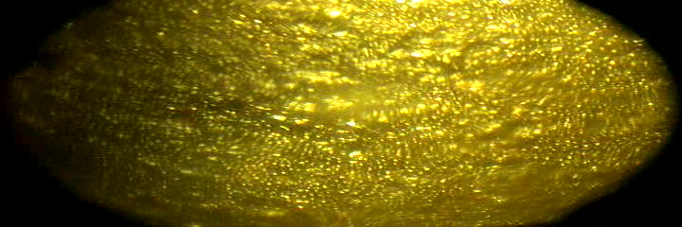

1. Spool #3 before pigging b) Spool #3 after pigging

Figure 7 – Sample pictures from bore scope observations

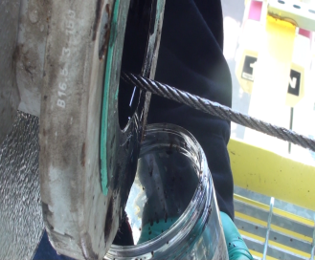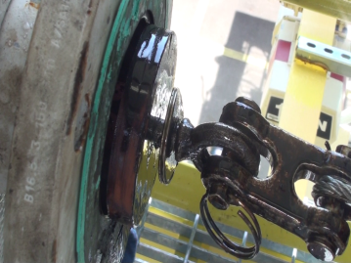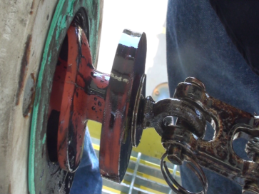

Figure 8 – Spool #3 pigging at 60 F

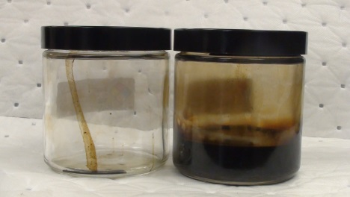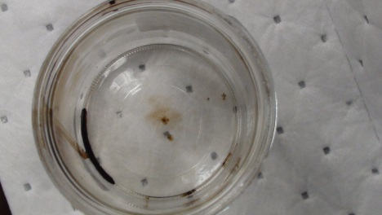

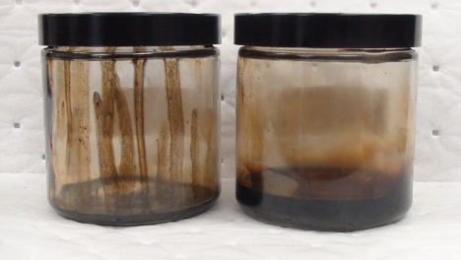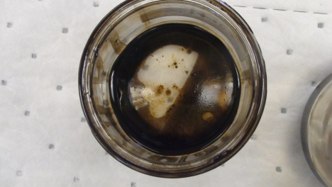

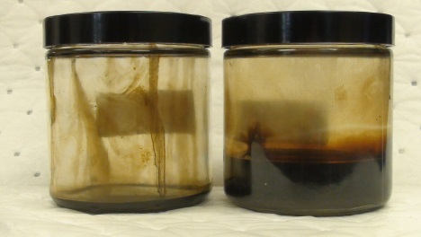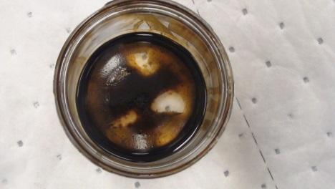

Figure 9 – Samples recovered during 60 F pigging. Spools #3

**Conclusion**

The amount of wax collected as well as the quality of the wax collected is different for different samples and a detailed analysis is required to draw conclusions.

**Chapter 4: The Procedure for measuring WAT using Cross Polarized Microscopy**

**Part (1): Slide preparation and Experimental Set Up**

* The sample is placed in an oven and the temperature is set to 50oC.
* The sample is allowed to stand for 1 hour
* The heated sample is centrifuged for approximately 2 minutes
* A new microscopic slide is taken and cleaned with a clean wiper
* A new clean syringe is used to transfer a drop of oil from the sample bottle to the microscopic slide
* A small microscopic glass cover is placed on the oil drop
* The slide is placed in the slide holder of the microscope
* The focus and the intensity of light is adjusted
* A suitable plane of focus is selected where wax is likely to be present and the intensity of light is adjusted using Auto-Exposure
* The Microscope is put in the birefringence mode and again Auto-Exposure is hit.
* If the temperature is close to the WAT, some wax can be seen otherwise the screen is black
* The ramp is set up and the results are recorded using the camera by taking a snapshot every second.
* The picture can be compiled at the end of the experiment into a video which can be analyzed later to determine the WAT.

**Part (2): Observation of WAT**

After the microscope has been set up and a temperature ramp is specified, the wax crystals, if there are any present initially (figure 10), starts to melt and the screen starts to go black (figure 11). The temperature at the last wax crystal dissolves is the Wax Dissolution Temperature. Once the upper limit of the ramp is reached, the system is held at that temperature for about 15 minutes to ensure that all the wax is completely dissolved. The system starts to cool at the specified rate and the temperature at the wax crystals first start to form is noted as the Wax Appearance Temperature. Figure 12 and figure 13 show the images captured by the camera at WAT and at a lower temperature when more wax crystals are formed respectively.

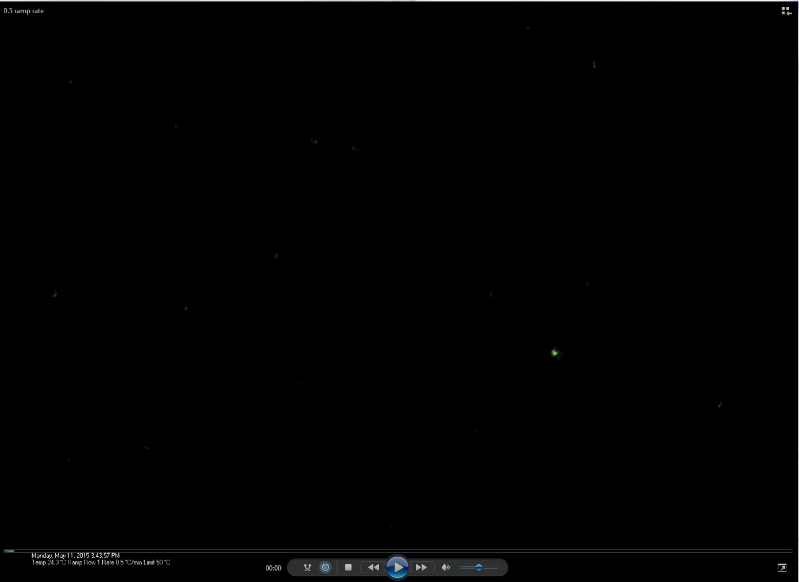

Figure 10: Initial picture taken at 24.3C on CPM

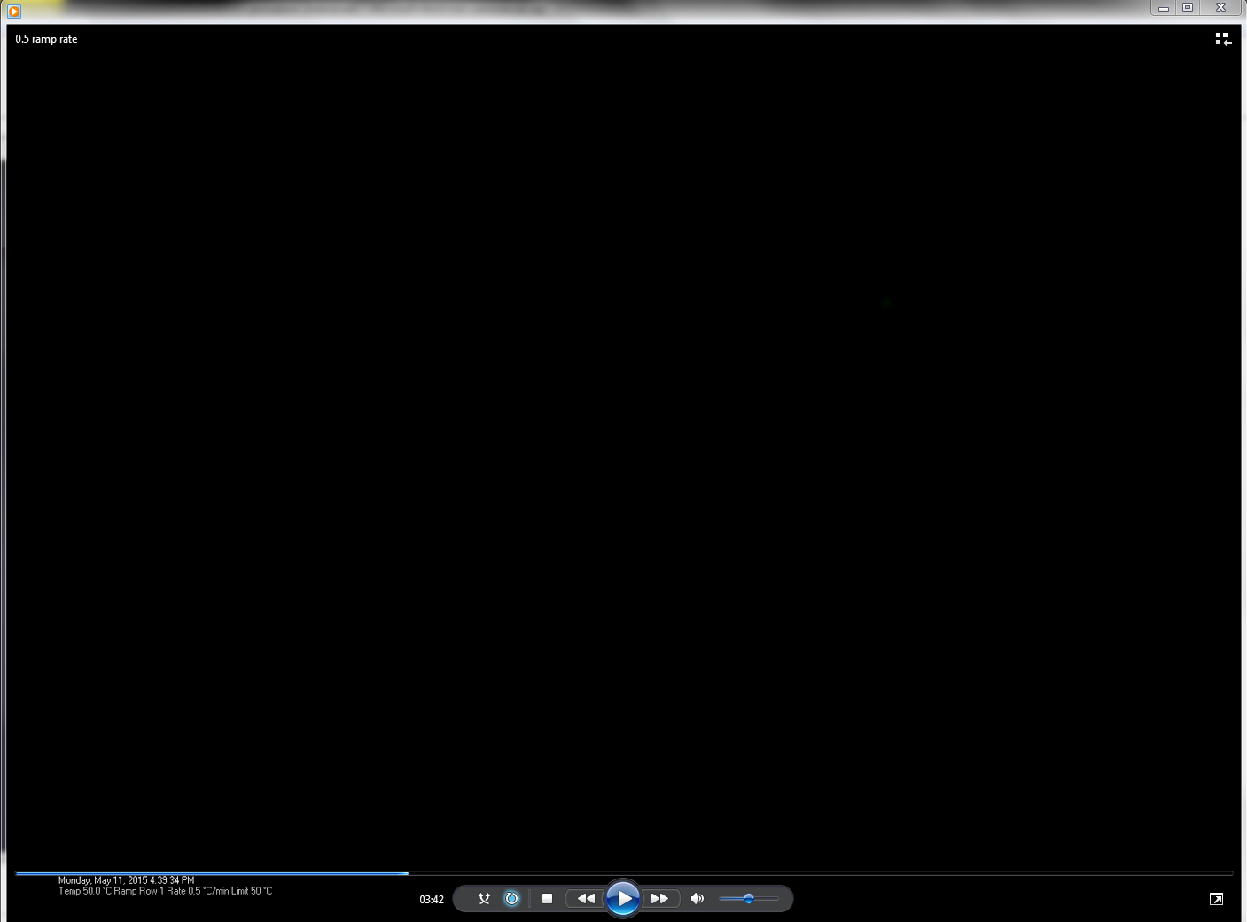  
Figure11: Screen is completely black at 50C

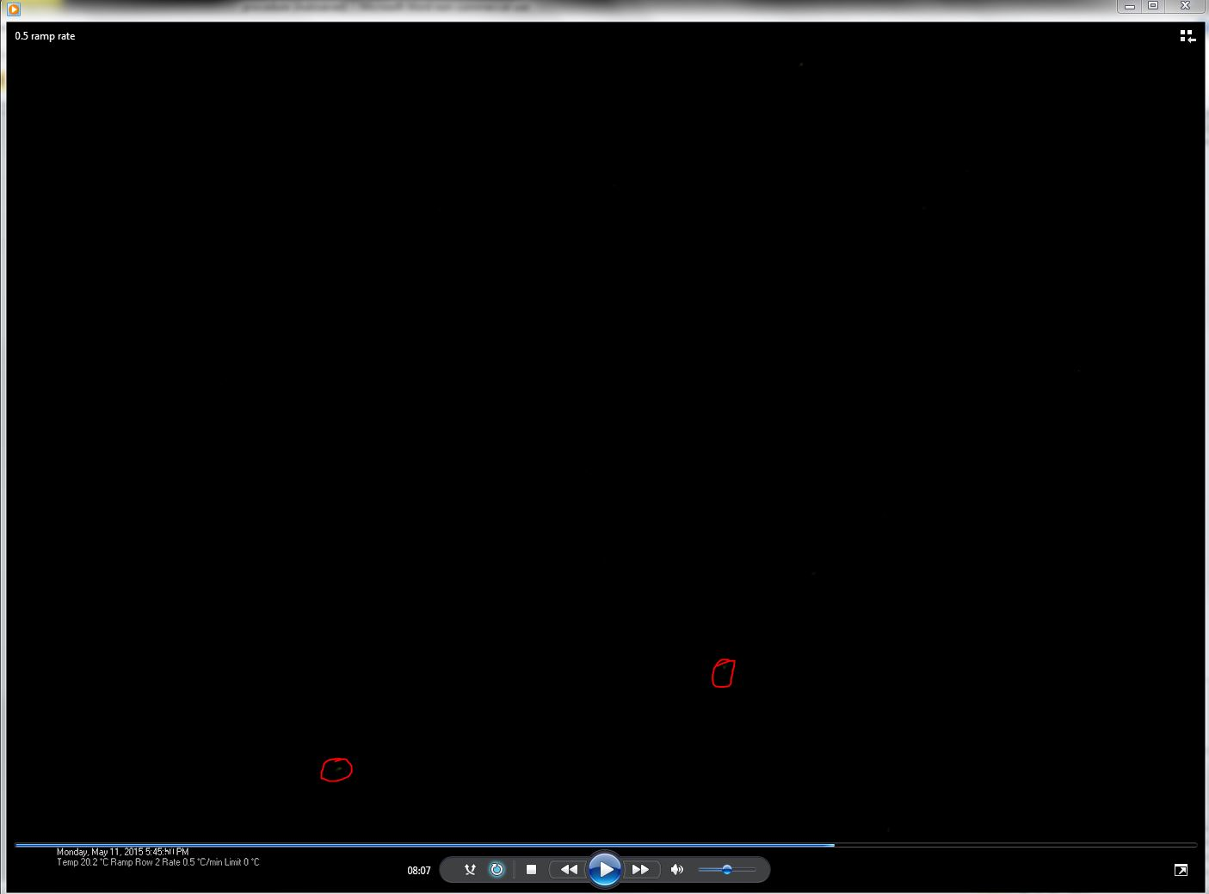

Figure 12: First crystals start to appear at between 20-20.5 C

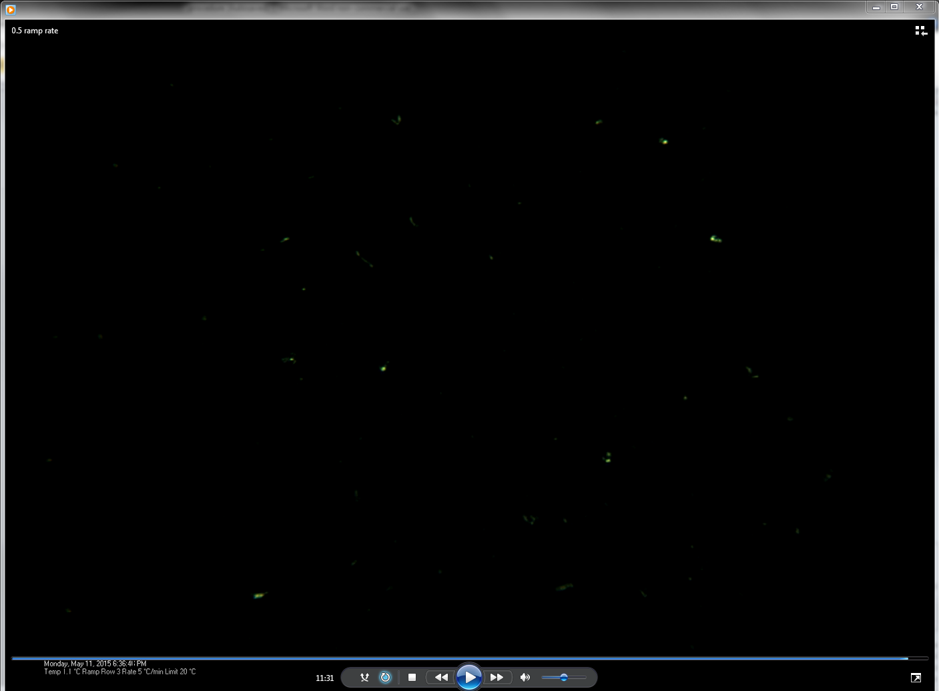  
Figure 13: A number of more crystals appear as the temp drops

**Chapter 5: MATLAB code for determining WAT and WDT**

**Image Processing: MATLAB**

Image processing is a powerful tool in MATLAB that has application in various fields today and can be used for determining the WAT and WDT of wax samples as well. As it has been mentioned earlier, the camera attached with the Cross Polarized Microscope, CPM, takes snapshots of the oil sample through the test at a specified delay time period. A MATLAB code has been developed which imports these pictures from a specified directly and processes them to give the required WAT and WDT. The concept of image processing is described in further detail below.

**Principle:**

The code converts each image in binary format. Pixel color 0 represents blackness whereas 1 represents wax crystals. The code reads the number of 1s in each image and plots that number versus the image number. Therefore, the image number where the number of 1s becomes zero represents the WDT, whereas, the image number where we first observe the deviation (wax crystals start appearing, increasing the number of 1s) gives the WAT. The code generates the graph and exports the data in an excel sheet which can be used for further interpretation. Figure 10 below shows a snapshot from one such excel sheet.

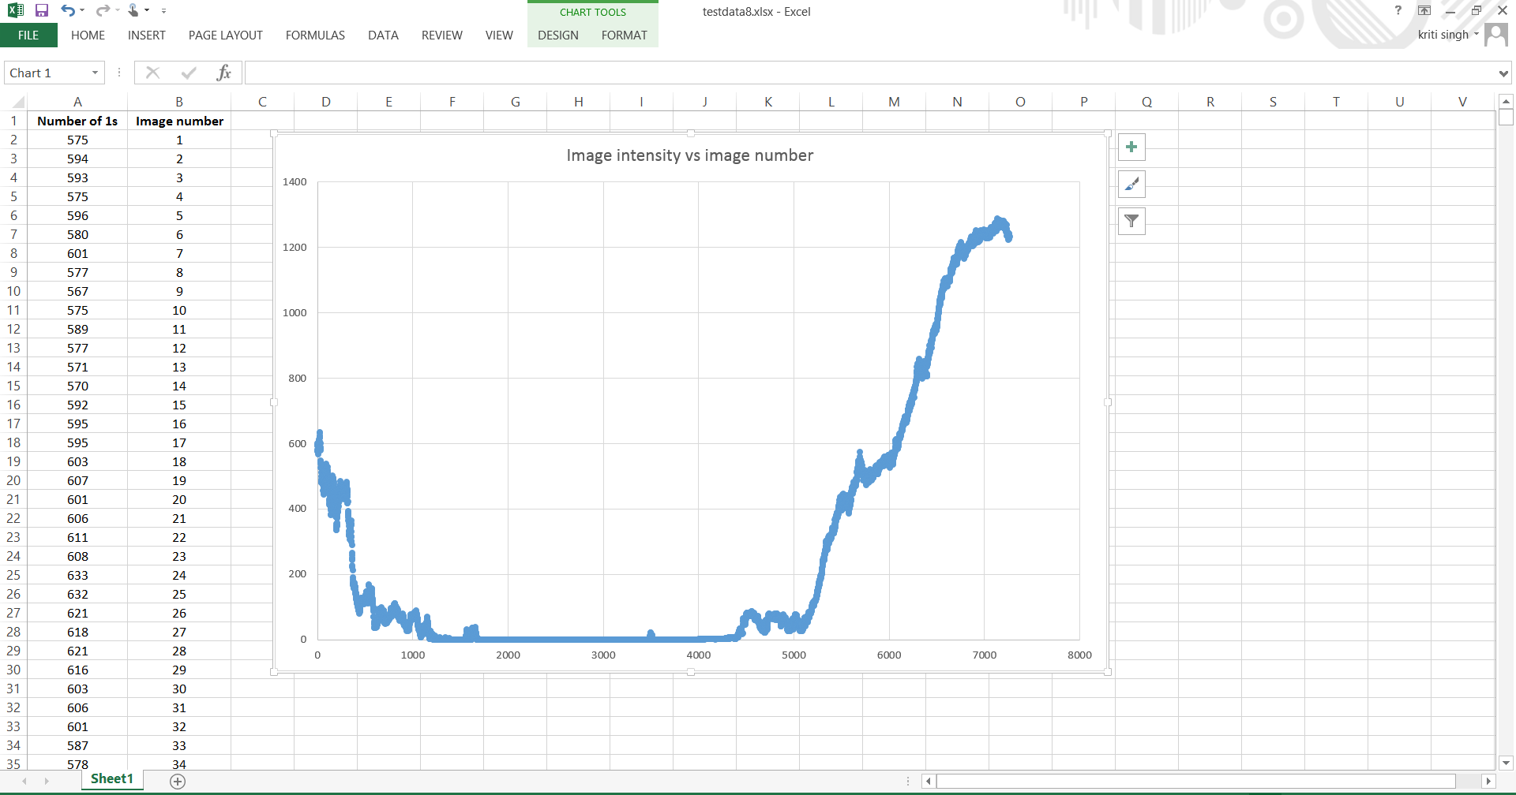  
Figure 14: A snapshot of excel file showing the graph and data produced by the MATLAB code

**Chapter 6: Effect of Cooling Rate on WAT**

**Experiment:** Cooling rate is known to have an effect on the WAT of crude oil. In order to study this relationship different tests have been conducted. A microscopic slide was made from sample number 012-A-029. Different tests were conducted on the same slide with different cooling rates. However, the ramp was similar for all the tests. Uniform heating and cooling rate was maintained throughout the test. The upper limit was set to 60C where it was held for 15 minutes while the lower limit was set to zero. The results have been summarized in table 1 below. Figure 14 show the graph between the cooling rate and the WAT.

|  |  |
| --- | --- |
| **Cooilng rate** | **WAT** |
| 0.1 | 29.5 |
| 0.5 | 27.3 |
| 0.8 | 26.5 |
| 1.2 | 26.1 |
| 2.5 | 24.6 |
| 5 | 21.6 |
| 10 | 20.8 |

Table 1: WAT corresponding to different cooling rate

Figure 15: A graph showing WAT vs cooling rate

**Discussion:** It can be clearly seen that the WAT decreases with the increase in the cooling rate. Though a further detailed study is required for drawing strong conclusions, one of the explanations, could be that at a high cooling rate, the system might not get enough time to adjust to the new temperature, and even though the temperature shown in according to the ramp, the oil sample might still be a relatively higher temperature. Therefore, it is very important to determine the optimum cooling rate which should be used so that we get accurate WAT and at the same time we do not spend a significant time on a single experiment.

**Chapter 7: Sensitivity Analysis of the Observed WAT on the CPM**

**Test Description:** In order to determine the accuracy of the WAT obtained from the CPM, a sensitivity analysis test was conducted. A sample 013-A-019 was selected and the WAT test was repeated five times on the same slide. A uniform heating and cooling rate of 0.5 degree per min was selected. The results observed are shown below in table 2.

|  |  |  |
| --- | --- | --- |
| Test Number | WAT [C] | Deviation |
| 1 | 27.3 | 0.6084 |
| 2 | 27.8 | 0.0784 |
| 3 | 28.1 | 0.0004 |
| 4 | 28.5 | 0.1764 |
| 5 | 28.7 | 0.3844 |
| Sum | 28.08 | 0.2496 |
| Mean (Average of all Observations) | | 28.08 |
| Variance (Average of deviation from the mean | | 0.2496 |
| Standard Deviation (Square root of variance) | | 0.49959984 |

Table 2: The WAT observed for the repeated tests on CPM on the same sample.

**Discussion:** The observation of WAT on the CPM is very subjective and a lot of factors may influence the result. There might be some noise present in some of the tests while some of the tests are very clean. Also, the plane of focus during the test has to be adjusted properly in order to make sure that the wax crystals are properly seen when they first start to form. Therefore, there are some human and instrumental errors associated with the CPM. However, despite these errors the WAT observed from repeating the test five times on the same sample is almost the same and the standard deviation is approximately 0.5, which is small.

However, this is a very basic test and a more thorough study is required to be conducted to draw strong conclusions. The tests can be repeated for different samples and also by conducting the experiment on different slides of the samples. The more data we can collect, the more accurate would be our standard deviation.

**Chapter 8: Preliminary Analysis of Different Tests Conducted on Flow Loop A and Loop B**

**Test Number: AFA2015-010**

**Test Description:** The loop was loaded on April 16 with TAPS oil (drums AL-004-008, AL-004-006 and AL-004-009) and NGLs were injected (cylinder #760061). The initial RVP was measured at 8.9 psia and initial water content was measured at 0.09%. Loop pressure was set to 40 psig. Cooling for the test was initiated on April 17 at noon. The cooling ramp was from 80 F down to 40 F at 5 F/hr. The loop was left at 40 F for 8 hours and then cooling resumed to 25 F at 5 F/hr. The table 3 below summarizes the results obtained from testing the samples on the CPM followed by a graphical presentation in figure 16.

|  |  |  |  |  |
| --- | --- | --- | --- | --- |
| **Sample Number** | **Date** | **Day ( From Baseline)** | **Temperature (F)** | **WAT** |
| 010-A-020 | Mon, April 20 | 2 | 25 | 25 |
| 010-A-028 | Wed, April 22 | 4 | 25 | 23.5 |
| 010-A-044 | Mon, April 27 | 9 | 25 | 24 |
| 010-A-054 | Thurs, April 30 | 12 | 25 | 24.5 |

Table 3: WAT observed for different samples on the CPM for test AFA2015-010

Figure 16: WAT as a function of time and temperature for test AFA2015-010

**Total Wax Collected:** 1110.1g

**Analysis:** The test is the first of the cold deposition tests; the temperature is maintained at 25F. We can see from the results that the WAT remains within a small range of 23.5 to 25 C and therefore, we can say that the WAT does not vary much with time while the temperature is constant. The wax collected is unusually high which might be the cumulative collection of the previous tests done till date.

**Test Number: AFA2015-012**

**Test Description:** The test was maintained at a temperature of 150 F via the steam line prior to draining the loop. Then test began with a fresh charge of crude. Oil was added from drums AL-007-002, AL-007-003, and AL-007-008. The fresh crude circulated at 110 F for 6 hours and NGLs were added to get an initial RVP of 9.0 psia. No water was added and the initial water content was about 400 ppm. The cooling ramp was then set at 5 F/hr to test temperature of 25 F. Cooling began at 20:30 PM on May 20 and reached 25 F on May 21 at about 9:30 AM. The test temperature was maintained at 25 F for the next 6 days prior to shut down and pigging. The flow rate is set to 45 gpm. The table 4 below summarizes the results obtained from testing the samples on the CPM followed by a graphical presentation in figure 17. The flow rate is set to 45 gpm

|  |  |  |  |  |
| --- | --- | --- | --- | --- |
| **Sample Number** | **Date** | **Day ( From Baseline)** | **Temperature (F)** | **WAT©** |
| 012-A-007 | Tue, May 19 | 0 | 105 | 25.5 |
| 012-A-017 | Thurs, May 21 | 2 | 25.6 | 23.5 |
| 012-A-020 | Fri, May 22 | 3 | 25 | 22.5 |
| 012-A-026 | Sun, May 24 | 4 | 25 | 22.7 |
| 012-A-029 | Mon, May 25 | 5 | 25 | 21.9 |
| 012-A-032 | Tue, May 26 | 6 | 25 | 22 |
| 012-A-036 | Wed, May 27 | 7 | 25 | 22.4 |

Table 4: WAT observed for different samples on the CPM for test AFA2015-012

Figure 17: WAT as a function of time and temperature for test AFA2015-012

**Total Wax Collected:** 393.3g

**Analysis:** We can see from the above graph that once the temperature is maintained at 25 F, the WAT does not change much with time. Hence we can further bolster the conclusion drawn from test AFA2015-010 that WAT does not change much with wax depletion over time. However, it should be noted that since the flow rate in this test was increased from 37 to 45 gpm to study the effect of increasing turbulence, there is a decrease in the WAT from an average of 24C in test AFA2015-010 to an average of 22C in the current test. Less thatn half of the total wax collected in test AFA2015-010 is collected in this test.

**Test Number: AFA2015-013**

**Test Description:** After the 150 F beneficiation at 150 F the loop was stabilized at 110 F before starting the cool down ramp to 25 F. The NGLs were maintained from the previous test and after injecting additional crude the RVP is 8.27 psia. Water was not added and the initial water content was approximately 200 ppm. The cooling ramp was then set at 5 F/hr to test temperature of 25 F. Cooling began at 13:25 PM on June 2nd and reached 25 F on June 3rd at about 7:30 AM. The test temperature was maintained at 25 F for the next 7 days prior to shut down and pigging. The flow rate is set to 45 gpm. The table 5 below summarizes the results obtained from testing the samples on the CPM followed by a graphical presentation in figure 18.

|  |  |  |  |  |
| --- | --- | --- | --- | --- |
| **Sample Number** | **Date** | **Day ( From Baseline)** | **Temperature** | **WAT** |
| 013-A-007 | Tue, June 2 | 0 | 115 | 21.5 |
| 013-A-013 | Wed, June 3 | 1 | 25 | 22.6 |
| 013-A-019 | Fri, June 5 | 3 | 25 | 24.5 |
| 013-A-028 | Mon, June 8 | 6 | 25 | 24 |

Table 5: WAT observed for different samples on the CPM for test AFA2015-013

Figure 18: WAT as a function of time and temperature for test AFA2015-013

**Total Wax Collected:** 387.3g

**Analysis:** It can be seen that as the temperature is dropped to 25 F from a baseline temperature of 115F, the WAT shows a slightly increasing trend. This might be because with the increase in the temperature difference, the wax starts to appear at a higher temperature. The amount of wax collected is equivalent to the amount collected in test AFA2015-012 which makes sense as the test conditions are same for both the tests.

**Test Number: AFB2015-009**

**Test Description:** The test was continued using the same charge as the previous test AFB2015-008 and adding oil to make up the test section volume. Oil was added from drums AL-007-004. NGLs were added to get an initial RVP of 8.74 psia. No water was added and the initial water content was about 500 ppm. The test was maintained at a temperature of 120 F for 24 hours prior to cooling at a rate of 5 F/hr. Cooling began at 14:00 PM on May 8 and reached 25 F on May 9 at about 11 AM. The test temperature was maintained at 25 F for the next 11 days prior to shut down and pigging. The table 6 below summarizes the results obtained from testing the samples on the CPM followed by a graphical presentation in figure 19.

|  |  |  |  |  |
| --- | --- | --- | --- | --- |
| **Sample Number** | **Date** | **Day ( From Baseline)** | **Temperature(F)** | **WAT C** |
| 009-B-009 | Thus, May 07 | 0 | 119 | 27.8 |
| 009-B-018 | Sun, May 10 | 1 | 25 | 28.1 |
| 009-B-052 | Wed, May 20 | 11 | 25 | 28.5 |

Table 6: WAT observed for different samples on the CPM for test AFB2015-009

Figure 19: WAT as a function of time and temperature for test AFB2015-009

**Total Wax Collected (All spools):** 454.7 g

**Analysis:** The WAT does not change much with time or temperature for the test. However, it should be noted that the total wax collected is higher as compared to the tests AFA2015-012 and AFA2015-013 on flow loop A. A possible explanation for this can be that the duration of the tests. The duration of this test is 11 days while that of the aforementioned tests on flow loop A was 6 days and 7 days respectively.

**Test Number: AFB2015-010**

**Test Description:** The test was maintained at a temperature of 150 F via the steam line after charging the loop with fresh crude. Oil was added from drums AL-007-007, AL-007-008, and AL-007-009. The fresh crude circulated at 110 F for 6 hours and NGLs were added to get an initial RVP of 8.6 psia. No water was added and the initial water content was about 200 ppm. The cooling ramp was then set at 5 F/hr to test temperature of 60 F. Cooling began at 11:45 AM on May 24 and reached 60 F on May 24 at about 5:00 PM. The test temperature was maintained at 60 F for the next 10 days prior to shut down and pigging. The table 7 below summarizes the results obtained from testing the samples on the CPM followed by a graphical presentation in figure 20.

|  |  |  |  |  |
| --- | --- | --- | --- | --- |
| **Sample Number** | **Date** | **Day ( From Baseline)** | **Temperature(F)** | **WAT C** |
| 010-B-024 | Sun, May 24 | 0 | 90 | 25.1 |
| 010-B-044 | Fri, May 29 | 5 | 60 | 24.5 |
| 010-B-062 | Wed, June 3 | 10 | 60 | 25 |

Table 7: WAT observed for different samples on the CPM for test AFB2015-010

Figure 20: WAT as a function of time and temperature for test AFB2015-010

**Total Wax Collected (All Spools):** 219.1g

**Analysis:** For this test, the WAT remains more or less the same with time and temperature. However, an important observation is to be made about the amount of wax collected. Since, it was a warm deposition test where the temperature was dropped to only 60F, significantly less amount of wax was collected as compared to other tests. This is despite the fact that the test duration was equivalent to that of test AFB2015-010.

**Test Number: AFB2015-011**

**Test Description:** The test was maintained at a temperature of 150 F via the steam line after charging the loop with fresh crude. The fresh crude circulated at 100 F for 6 hours and NGLs were added to get an initial RVP of 8.6 psia. No water was added and the initial water content was about 200 ppm. The cooling ramp was then set at 5 F/hr to test temperature of 55 F. The flow rate was maintained at 45gpm. The table 8 below summarizes the results obtained from testing the samples on the CPM followed by a graphical presentation in figure 21.

|  |  |  |  |  |
| --- | --- | --- | --- | --- |
| **Sample Number** | **Date** | **Day ( From Baseline)** | **Temperature(F)** | **WAT C** |
| 011-B-014 | Sat, Jun 6 | 0 | 100 | 28 |
| 011-B-018 | Sun, Jun 7 | 1 | 55 | 28.1 |
| 011-B-025 | Tue, Jun 9 | 2 | 55 | 28.7 |
| 011-B-034 | Fri, June 11 | 6 | 55 | 28.8 |
| 011-B-040 | Sun, Jun 14 | 8 | 55 | 29 |
| 011-B-042 | Mon, Jun 15 | 9 | 55 | 28.5 |
| 011-B-045 | Tue, Jun 16 | 10 | 55 | 28.5 |
| 011-B-049 | Wed, Jun 17 | 11 | 55 | 28.8 |

Table 8: WAT observed for different samples on the CPM for test AFB2015-011

Figure 21: WAT as a function of time and temperature for test AFB2015-011

**Analysis:** The WAT does not change significantly for this test with time or temperature.

**Chapter 9: Conclusion**

The Wax Appearance Temperature, WAT is very crucial for dealing with the wax deposition problem. Therefore, in this work, efforts have been made to learn more about the WAT. However, equal emphasis has been laid on studying the wax deposition phenomena. Therefore, a thorough literature review has been done covering the breakthrough work and models. In addition to that, the most recent work done in this area has also been covered. The application of intelligent modelling seems to be promising on account of the relatively less financial resources required and the robustness and accuracy it offers. Therefore, it can be explored further.

The Cross-Polarized Microscopy is popularly used to measure the Wax Appearance Temperature. Sensitivity analysis experiments were conducted to measure the error associated with the CPM. It was observed that the error is relatively small, standard deviation of approximately 0.5. However, this does take into account the human error involved since the process is very subjective. Therefore, the experiments need to be conducted with good skill and technique. A MATLAB code was also developed to measure the WAT using Image Processing. A next step is to measure the accuracy of the code. This can be done by comparing the WAT observed from the CPM and the code.

Tests were conducted to understand the effect of the cooling rate on the WAT. The results showed that the WAT is an inverse function of the cooling rate and the WAT for the same sample reduces for higher cooling rate. Therefore, there is a need to select an optimum cooling rate for measuring an accurate WAT.

Various tests were conducted on the arctic flow loop built in the University of Tulsa to simulate the flow conditions of the Trans-Alaska Pipeline in order to study the wax deposition phenomena in detail. The observations and analysis of the various tests have been discussed under each test. However, overall conclusion that we can make is that the WAT depends more on the temperature difference between the bulk oil and glycol, but it does not depend much on time and wax depletion associated with it. The wax deposition thickness on the other hand is a function of both time and the temperature difference. However, a more detailed study with more data is required to draw stronger conclusions.

**References**

Adeyemi B.J., Sulaimon A.A. Predicting Wax Formation Using Artificial Neural Network. Society of Petroleum Engineers, SPE 163026.

Apte, M. Investigation of Paraffin Deposition in Multiphase Flow. MS Thesis, the University of Tulsa, Tulsa, Oklahoma, 1999.

Bern, P.A., withers, V. R. and Cairns, R. J. R.: Wax Deposition in Crude Oil Pipelines. European Offshore Petroleum Conference and Exhibition*,* London, England, October 21-24, 1980.

Brown, T. S., niesen V.G., E Erickson, D. D. Measurement and prediction of the kinetics of paraffin deposition. Society of Petroleum Engineers, 26548: 353-368, 1993.

Burger, E.D., perkins T.K. , striegler, J.H. Studies of wax deposition in the Trans Alaska Pipeline. Journal of Petroleum Technology, 1075-1086, 1981.

Hernandez, O.C. Investigation of Single-Phase Paraffin Deposition Characteristics, M.Sc. Thesis, the University of Tulsa, 172pp.

Kamali V., Jalalnezhad, M.J. Development of an Intelligent Model for Wax Deposition in Oil Pipeline. February 2015.

Kamari, A., Manshad, A., Gharagheizi F., Mohammadi A.H., Ashoori, S. Robust Model for the Determination of Wax Deposition in Oil Systems. Industrial and Engineering Chemistry Research. 15664-15672, 2013.

Krasovitskii, B. A. and MAron, V. I., 1981. Growth of Paraffin Deposits on the Pipe Wall. Inzhenerno-Fizichaskii Zhurnal, Vol. 40, No. 4, pp. 683-689.

Lund H.: “Investigation of Paraffin Deposition during Single Phase Flow”, MS Thesis, the University of Tulsa, Tulsa, Oklahoma 1998.

Matzain A.: “Multiphase Flow Paraffin Deposition Modelling”, PhD Dissertation, the University of Tulsa, Tulsa, Oklahoma 1999.

Rosvold, K. Wax Deposition Models, M.Sc. Thesis, Department of Petroleum Engineering and Applied Geophysics, Norwegian University of Science and Technology, Trondheim, 104pp.

Singh, P. Gel Deposition on Cold Surfaces. The University of Michigan, PhD Thesis.

Svendsen, J.A., 1993. Mathematical Modelling of Wax Deposition in Oil Pipeline Systems. AIChE Journal, Vol. 39, No. 8, pp. 1377-1388.

Todi, S., 2006, “Experimental and Modeling Studies of Wax Deposition in Crude-Oil-Carrying Pipelines,”. Offshore Technology Conference 18368.